# **Procedure CDP08- Embedded Development**

# **Design:**

The system does not have any Arduino or other micro processor involved so we can’t have any circuit diagram of the system. Following are the three dataflow diagrams of the system:

## **Level 0 Data Flow diagram:**

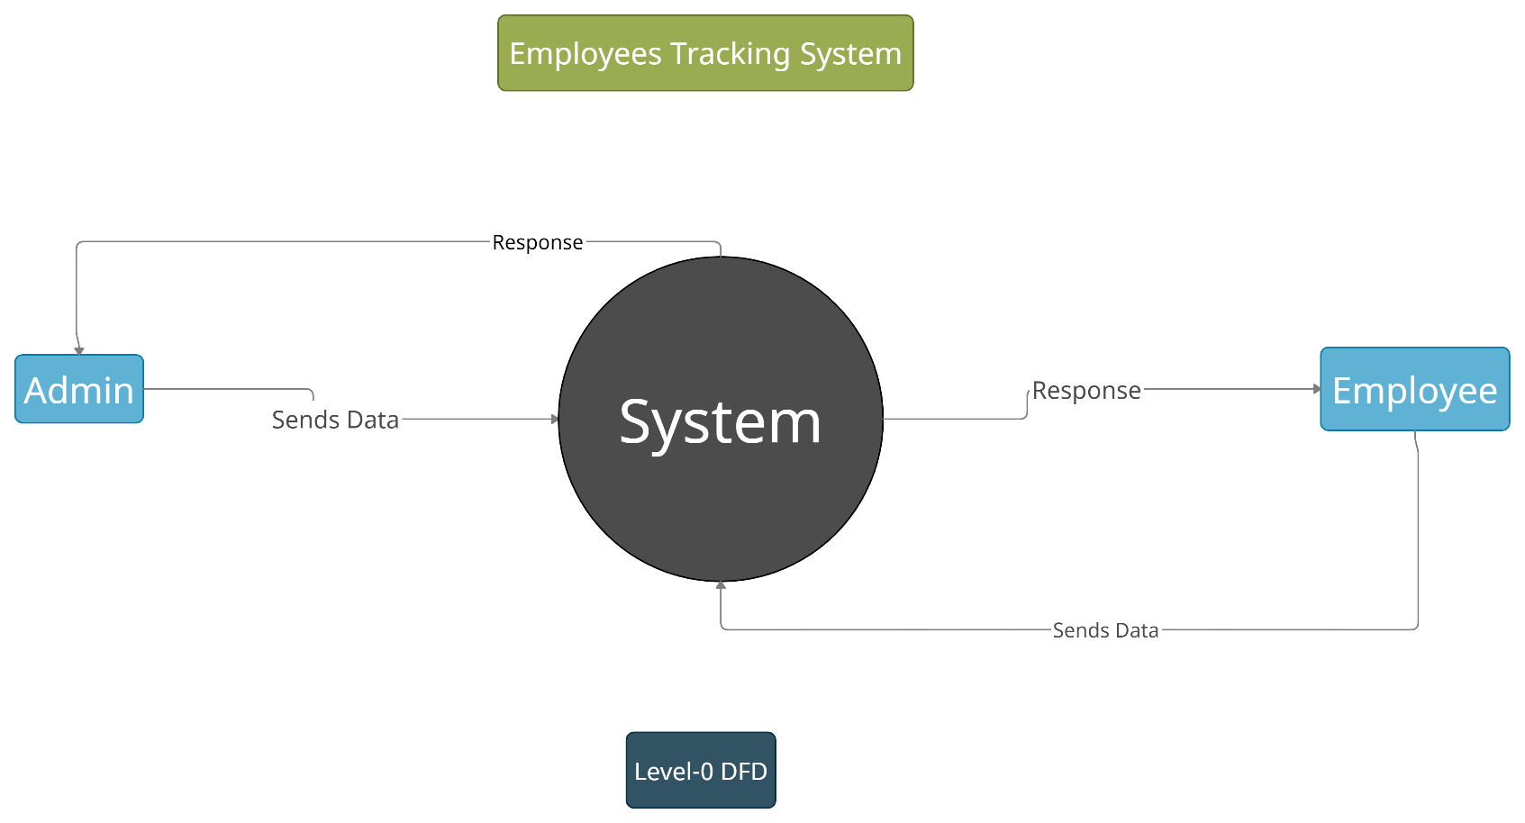

*Level -0 DFD*

## **Level-1 Data Flow Diagram:**

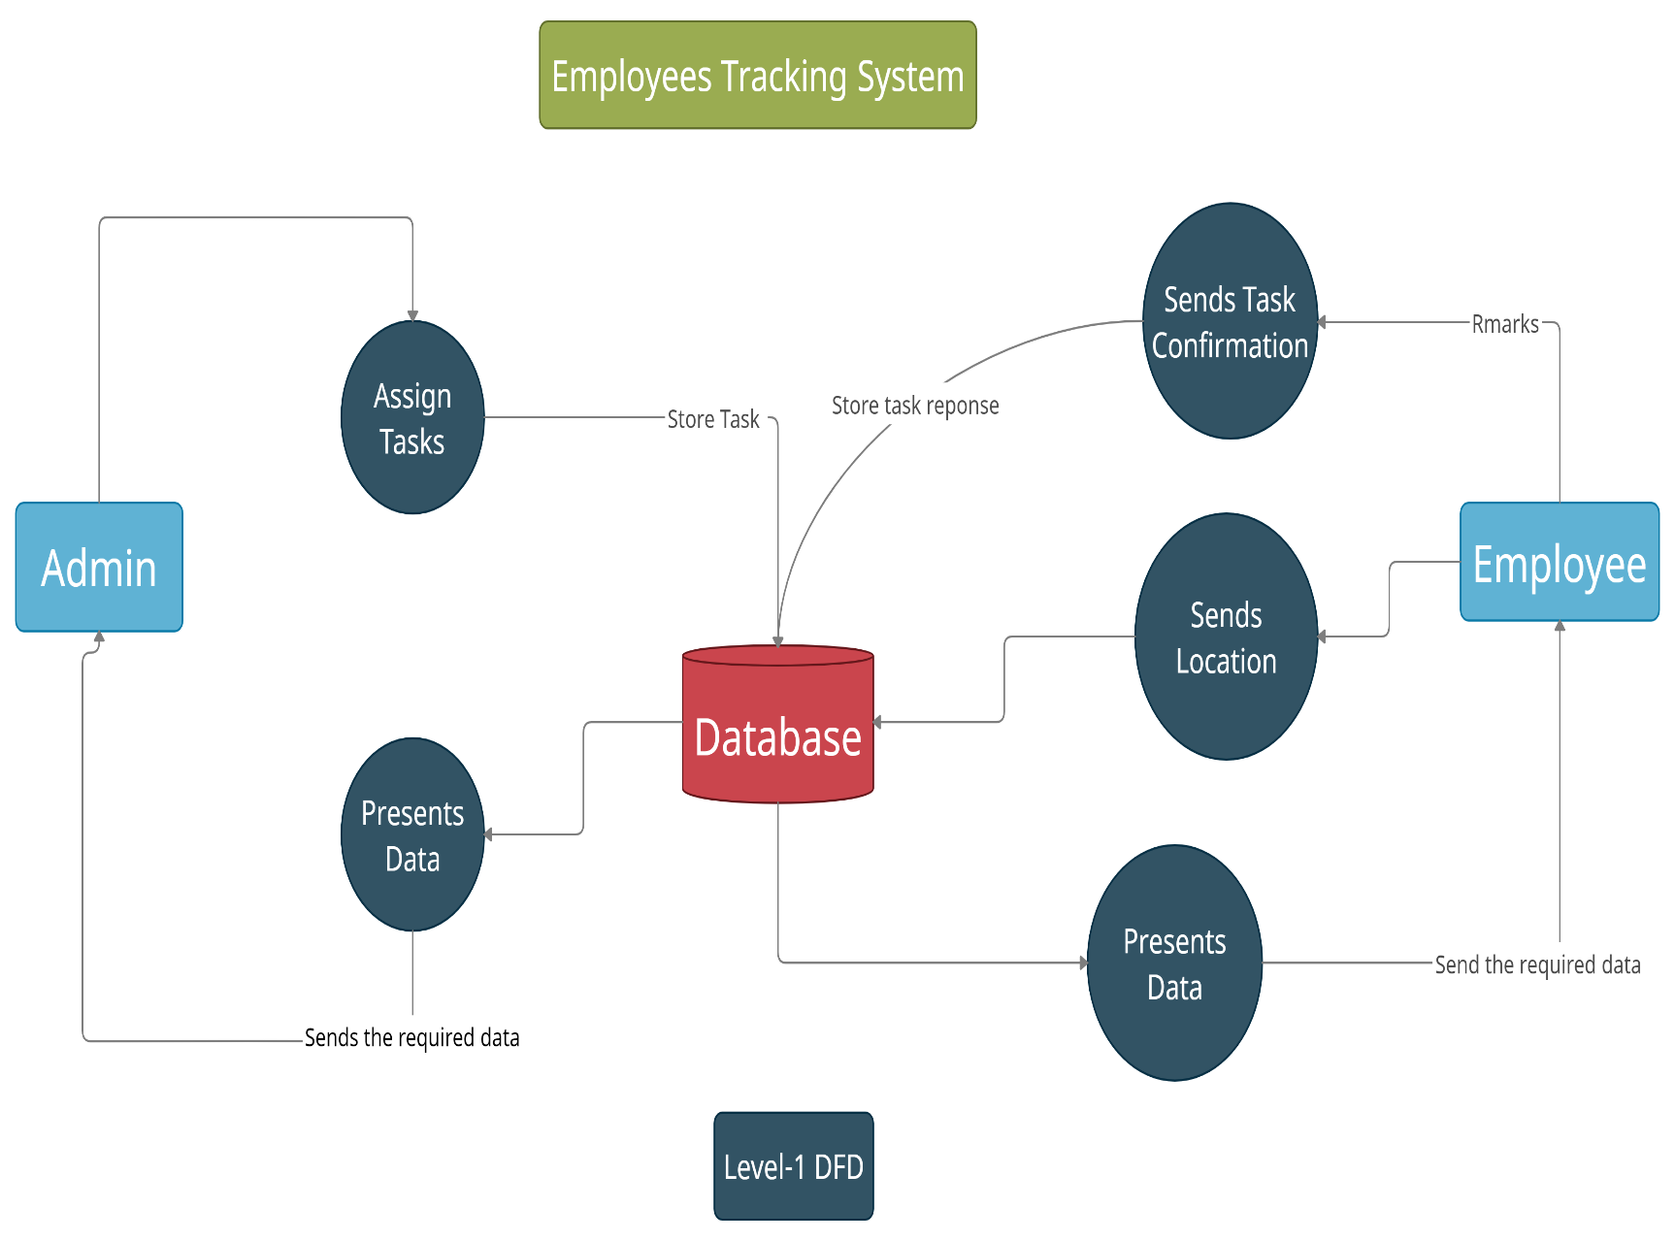

*Level- 1 DFD*

## **High Level Data Flow Diagram:**

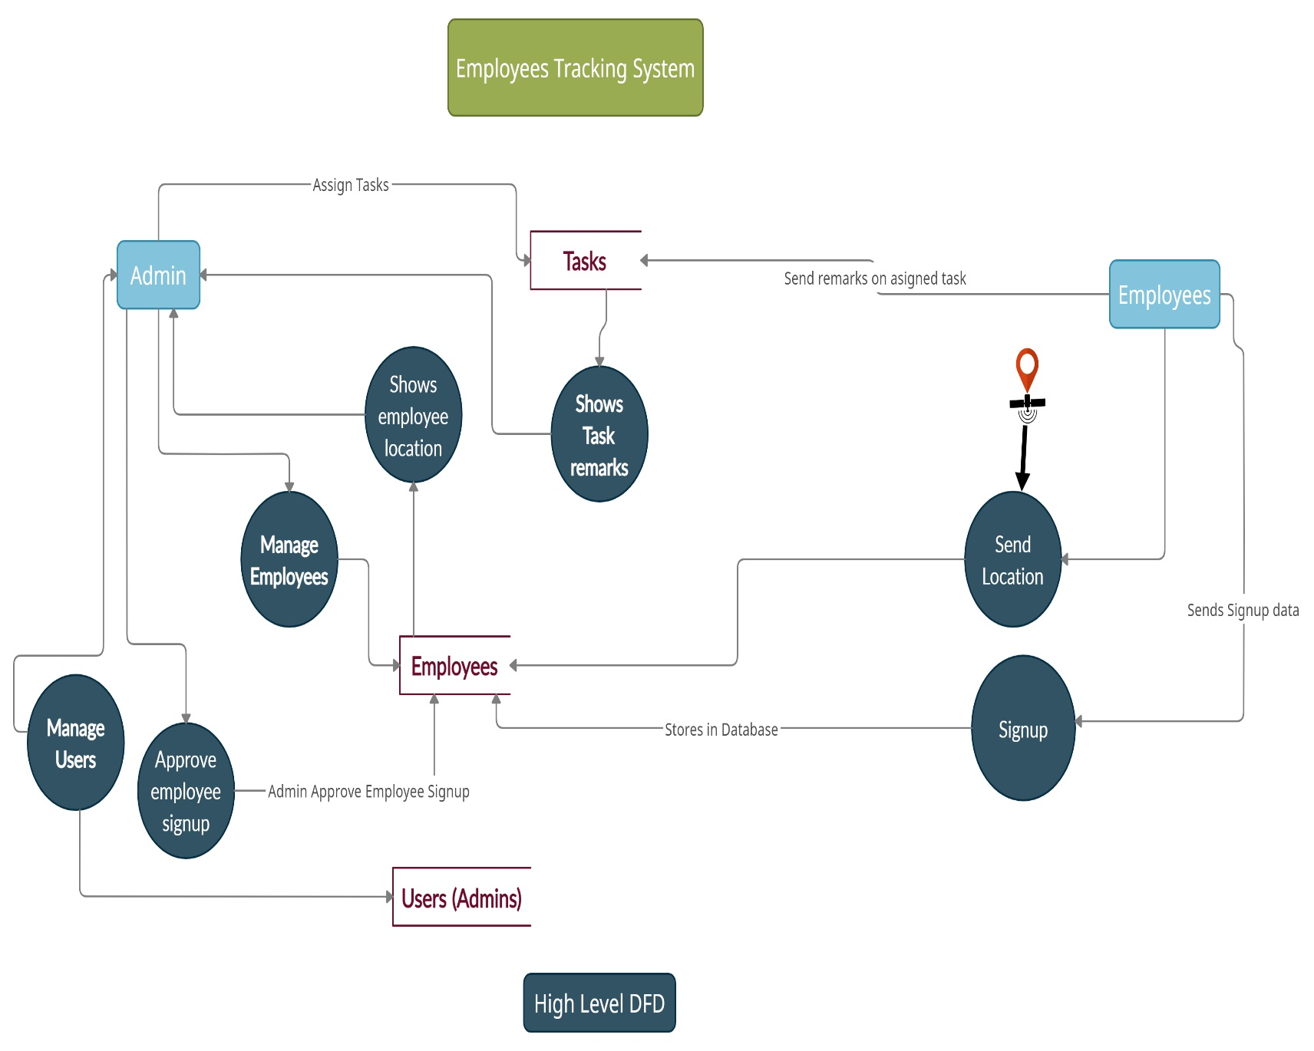

*High Level DFD*